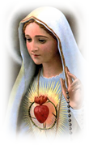
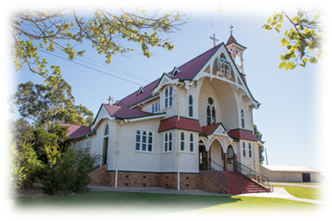
St. Mary’s Catholic Parish Beaudesert

EMBRACING THE COMMUNITIES OF:
St Mary’s, Beaudesert ~ St John the Baptist ~Tamborine Mountain ~
St Patrick’s, Tamborine ~ St Margaret Mary’s, Canungra ~
St John’s, Kerry ~ The Sacred Heart, Christmas Creek ~
St Joseph’s, Rathdowney ~ St James’, Palen Creek ~ St Joseph’s, O’Reilly’s
________________________________________________________________

Sacramental Preparation Programme – 2020
1st Holy Communion – Year 4 and above those Confirmed in 2019
St Mary’s
Parent Meeting: Monday 3rd February at 4pm & 7pm at St Mary’s Church
Lessons: Monday 10th, 17th February at 4pm. Di Hoyle will conduct these lessons in the Parish Centre
Workshop: Friday February 21st at 3.30pm at St Mary’s Church
Receive Sacrament: Sunday 23rd February at 9.30am Mass OR 5.30pm Mass

Reconciliation – Year 5 and above
St Mary’s
Parent Meeting: Monday 16th March at 4pm at St Mary’s Church
Lessons: Monday 23rd March at 4pm with Di Hoyle at St Mary’s Church
Receive Sacrament: Saturday 28th March at 4pm to 5pm at St Mary’s Church

Confirmation – Year 3 and above
St Mary’s
Parent Meeting: Monday 20th July 4pm and 7pm at St Mary’s Church
Enrolment Mass: Saturday 25th July at 6.30pm and Sunday 26th July at 9.30am or 5.30pm Mass
Saturday 1st August at 6.30pm and Sunday 2nd August at 9.30am
Lessons: Tuesdays - 28th July, 4th August and 11th August at 4pm at Parish Centre – Di Hoyle to conduct
Receive Creed: Saturday 15th August at 6.30pm or Sunday 16th August at 9.30am
Workshop: Tuesday 18th August at 3.30pm at St Mary’s Church

Confirmation: Receive Sacrament: Friday 21st August at 6pm

